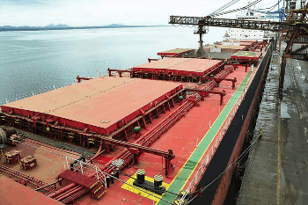
Quantity for Order Many commodity products such as grains and solids are transported by special cargo ships, the so-called freighters.
The standard stipulated quantity for commodity for bulk orders:
commodity for bulk orders12.500 metric tons (MT)

25.000 metric tons (MT)

50.000 metric tons (MT)

75.000 metric tons (MT)

100.000 metric tons (MT)

150.000 metric tons (MT)

200.000 metric tons (MT)

300.000 metric tons (MT)

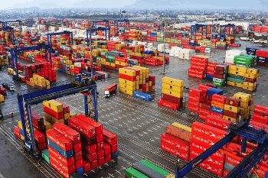
Container Size
The standard stipulated quantity for merchandise
for container orders and small quantity:
container orders Container 20 FEET - Dimensions:

internal: 5,900 m long X 2,350 m wide X 2,393 m high, with a cubic capacity of 33.2 m.
external: 6,058m long X 2,438m wide X 2,591 m high and maximum capacity of 24,000 kg.

Container 40 FEET - Dimensions:

internal: 12,032 m long X 2,350 m wide X 2,392 m high, with a cubic capacity of 67.7 m.
external: 12,192m long X 2,438 m wide X 2,591 m high and maximum capacity of 26,930 kg.

